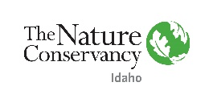

Trustee Fellowship Application, Idaho Chapter

Name of Candidate:
Recommended by: Date:

Candidate’s Address (Work & Home):

Candidate’s Phone Number and Email Address:

University/Program or Organization Associated with:

Area of Study/Professional Experience

______Public Policy
______Science, specific area __________________
______Natural Resources
______Environmental Studies
______Law
______Media/Marketing
______Business
______Non-Profit Administration
______Other

Please return this application and attach the three items listed below via email to Valerie Connor: vconnor@tnc.org Trustee Liaison, The Nature Conservancy in Idaho.

_____ Personal and Academic Curriculum Vitae (not more than 2 pages)

_____ Personal Education and Career Goal Statement emphasizing applicant’s interest in, contribution to, and expectations from the Fellowship (1,000 words or less)

_____ Letter of Recommendation from a professor/advisor or someone familiar with the applicant’s abilities

Deadline for Applications October 1, 2020

